Schedule C / Annexe C

ACM Author’s Rights Form Workflow – Suivi des formulaire de droits des Auteurs dans ACM

ACM Open Author eRights Experience

Welcome to ACM Open!

This document will explain the experience when an author from your institution chooses to publish in an ACM conference or journal. It is extremely important that your authors are listed as the corresponding author and use their institutional email address when submitting their work, so they are provided with the correct ACM Open eRights forms.

An email similar to the one below is sent to the corresponding author of a manuscript in each of these instances:

• Submission to an ACM journal
• Acceptance to an ACM journal
• Acceptance to an ACM conference (will be used for demo purposes below)

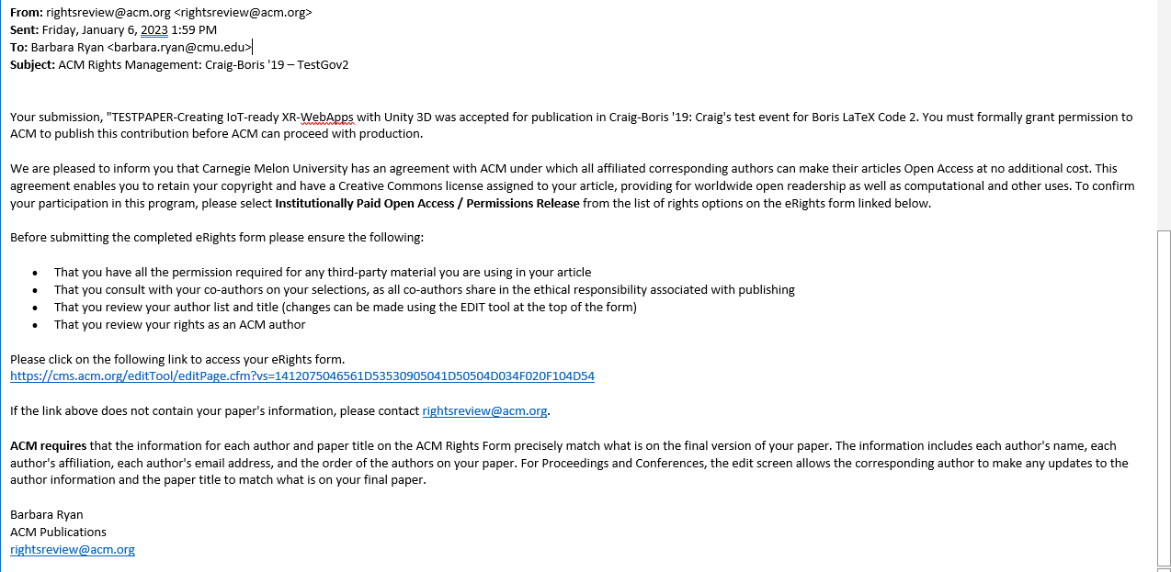

When the corresponding author, (the author who received the email with the link to the eRights form), clicks on the link to the eRights form they are brought to an edit screen. If the paper is part of the ACM Open Program, the ACM Open Edit Screen will have a line at the top saying “This paper is part of the ACM Open Program”. (The eRights system recognizes the corresponding author is from a participating institution based on the email domain provided to us by the institution’s administrator). If the corresponding author changes their email address, from their institutional domain to a non-institutional domain*, their paper will no longer be part of the ACM Open Program.

The corresponding author should confirm all information on the edit screen to make sure the title and all the author information is correct. Once the corresponding author has reviewed the information and determines it is correct, they should click on the check box and then click on Proceed to eRights Form button:
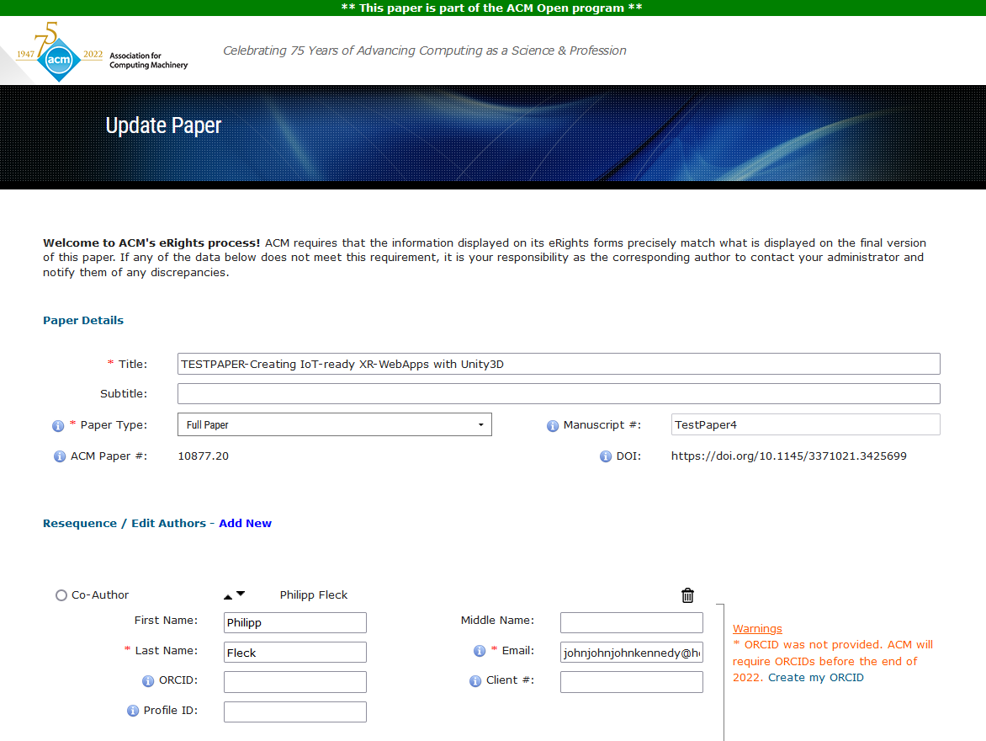

*Authors may change their email address because they are no longer at the institution and do not have access to that email inbox anymore.

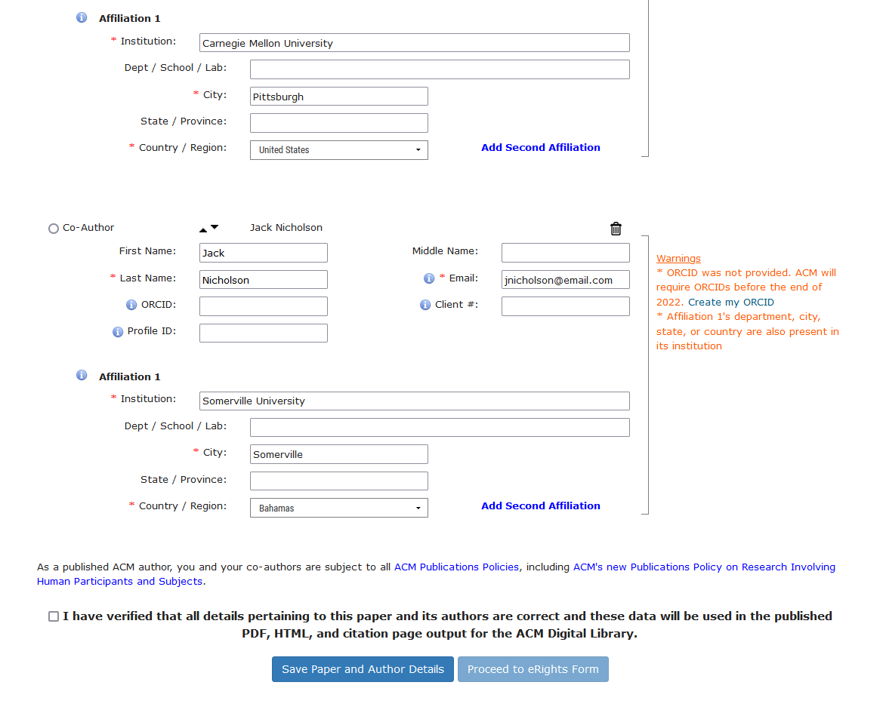

Clicking on the Proceed to eRights Form button will bring the corresponding author to the ACM eRights Form (samples below). The ACM Open eRights Form defaults to the Institutionally Paid Open Access rights and a Creative Commons CC-BY 4.0 License. The corresponding author is allowed to change the options (but the default options is recommended and may be requested by your institution).

For the corresponding author to choose a Creative Commons License they cannot change the rights option from Institutionally Paid Open Access to Exclusive License to Publish.

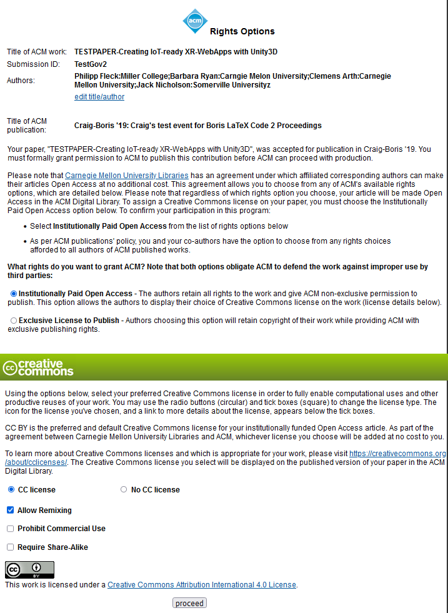

The next six screen shots show the different Creative Commons Licenses the corresponding author can choose from by clicking on the different radio buttons.

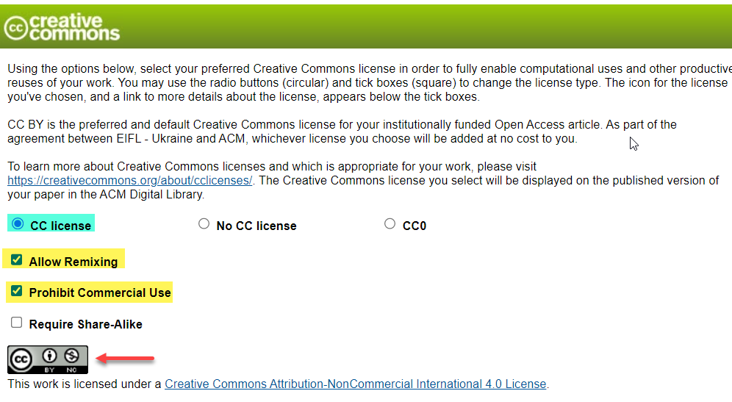

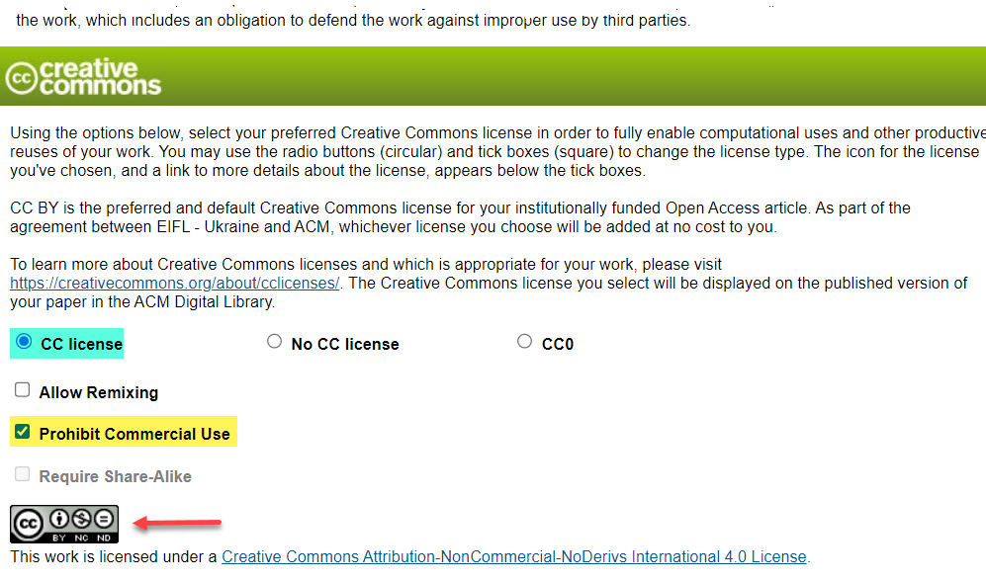

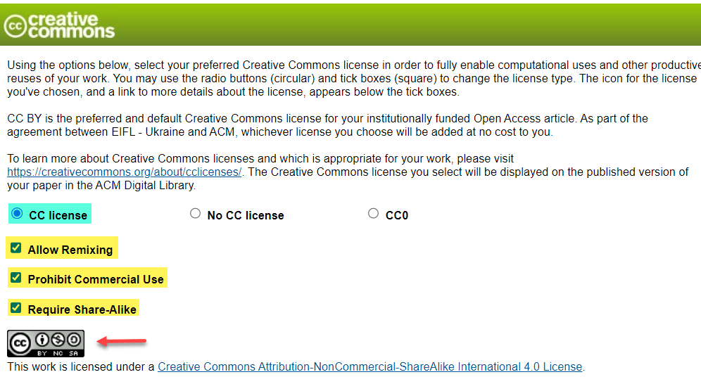

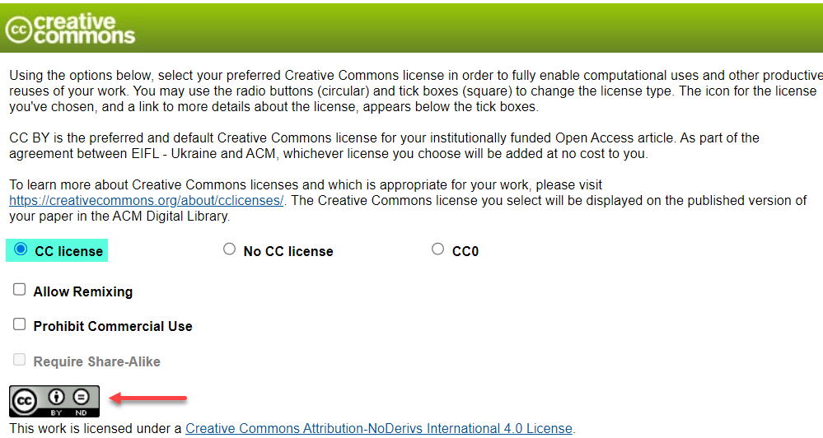

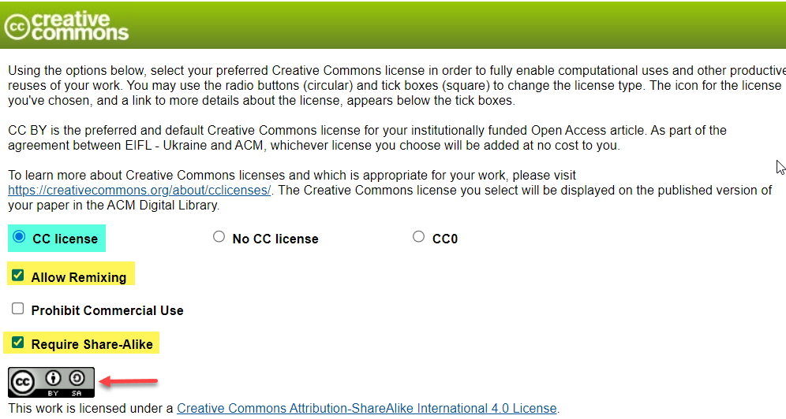

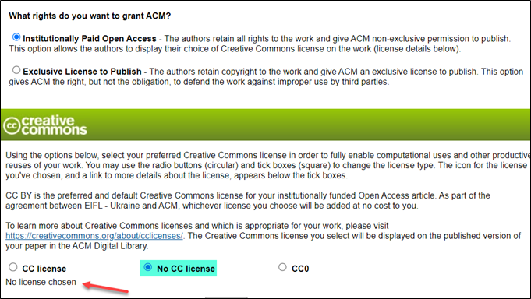

After selecting their Creative Commons license and clicking the Proceed button, the corresponding author will see the following details which gives ACM the permission to publish their work:

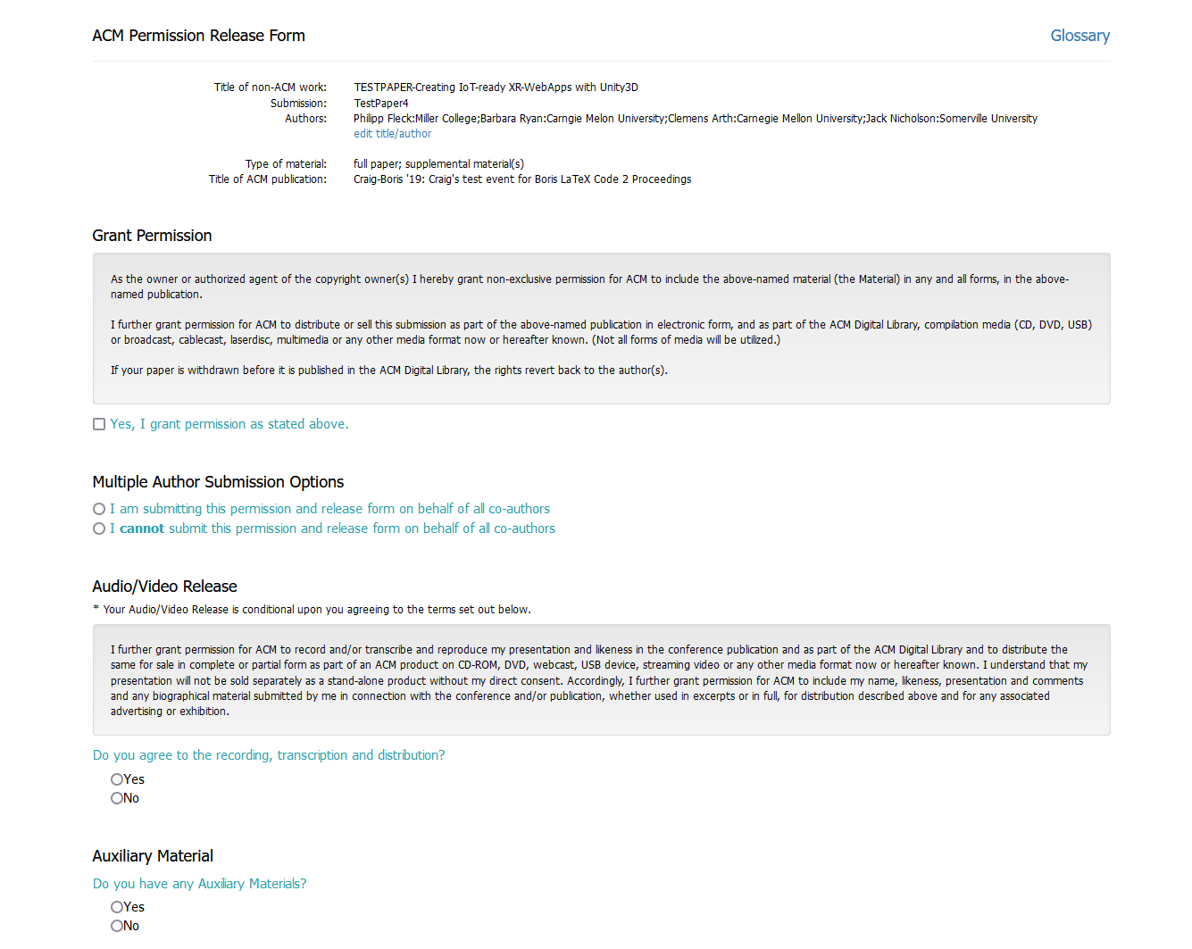

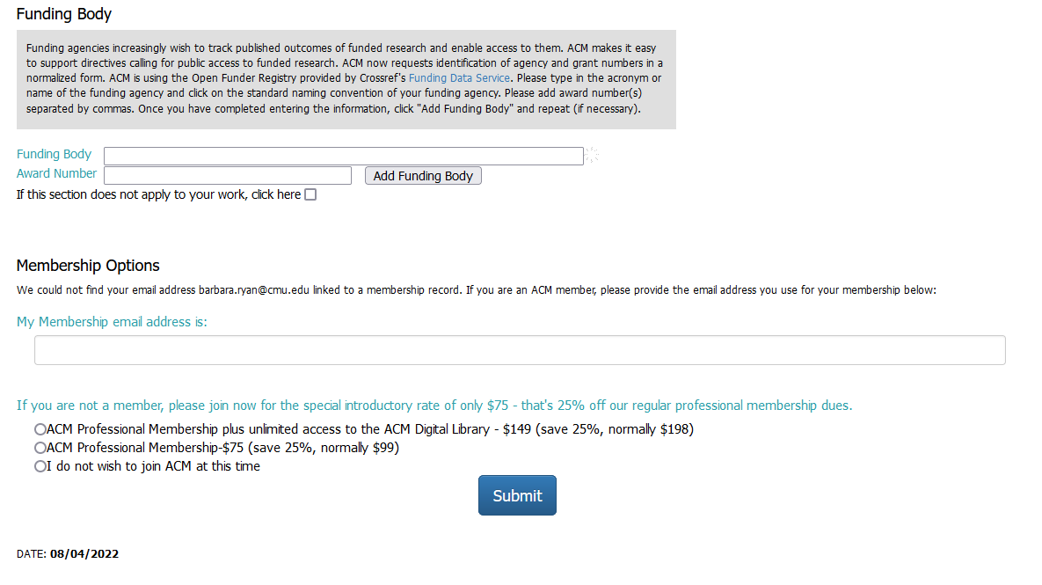

Following submission of their eRights Forms, the corresponding author will receive email confirmation of the acceptance of the forms along with a copy for their records.

If you have any questions about the eRights process for ACM Open institutions, please reach out
to rightsreview@acm.org or your account manager.

For the Publication Rights & Licensing Policy, visit the ACM Publication Policy.

